B.C.M. Sen. Sec. School, Basant City, Pkh. Road, Ludhiana
Name ___________________ Roll No._____ Standard II
Chapter (4, 5)
- Colour the following picture and name the commands using to draw hut.

1.____________________
2.____________________
3.____________________
4.____________________
5.____________________

- Name the different buttons in the Ribbon.
Font Size
Font Family

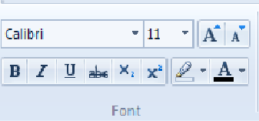
Underline
Bold
Italic

Q3:- Answer the following questions.
- Name any two tools present in the Tools group.
Ans. Pencil, Eraser.
- What is Microsoft Paint?
Ans. Microsoft paint is a drawing program.
- Which button closes the WordPad window?
Ans. Close button.
- Which of the following shows a menu of options?
Ans. WordPad button
- Which tool is used to draw Sun?
Ans. Oval tool , Line tool .
Q4:- Match the following:

- 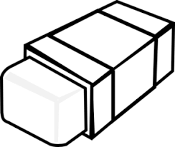 | Fill with Color tool
 | Eraser
 | Brushes
 | Pencil Tool

