B.C.M. Sen. Sec. School, Basant City, Pkh. Road, Ludhiana
Name ___________________ Roll No._____ Standard II
Chapter (2, 3 )
- Colour the mouse buttons according to the colour given.
      - Left Button: Blue
      - Right Button: Orange
      - Scroll Wheel: Pink
      - Mouse Body: Yellow

- Given below are the qualities of man and computer, color the qualities of computer with Green color and that of man with Red color
Fast
Can thick
Can feel

Accurate
More Storage
Take Decision

Tireless
Intelligent
Use electricity

- Follow the directions given below and color the picture with your crayons.
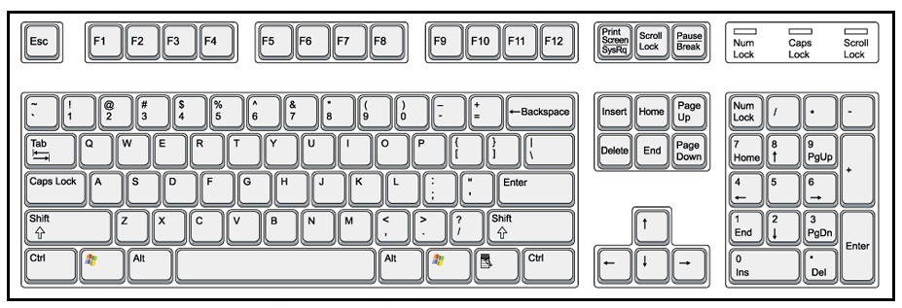
- Keys that spell your name and surname. (use Orange color)
- Key which adds space between your name and surname. (use Red color )
- This is your Eraser. (use Green color)
- Keys which type your Age. (use Blue color)

- True/False
T
- You Can Play games on computer.
F
- We use the Caps Lock key to type small letters.
T
- Computer help at office.
- The Backspace key is like an eraser.
T

- Answer the following questions.
- Why we use computer at home ?
Ans. Play games,Listen Music,Online Shopping
- What is the different types of keys on the Keyboard.
Ans. Alphabet Keys, Number Keys, Special Keys.
- What is Robot?
Ans. A robot is a machine.
- Which is the longest key on the keyboard?
Ans. Space Bar Key
- Write is a mouse ? What does it do?
Ans. A mouse is a pointing device. It is used to point and select the items.
- Match the following:
Mouse | 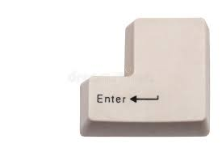
Space Bar Key | 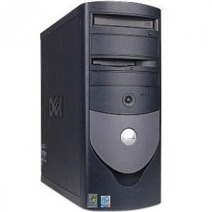
CPU

Enter Key | 